**Excel Assignment – 9**

1. What are the different margins options and do we adjust the margins of the excel worksheet?

Answer: There is three different margin options Normal, Wide and Narrow.

Other than that we also have custom margin setting. To specify custom page margins, click Custom Margins and then in the Top, Bottom, Left, and Right boxes enter the margin sizes that required.

Yes, we do need to adjust margins, to get desired print layout and it sometimes help to get the print in one page by reducing the margins.

2. Set a background for your table created.

Answer:

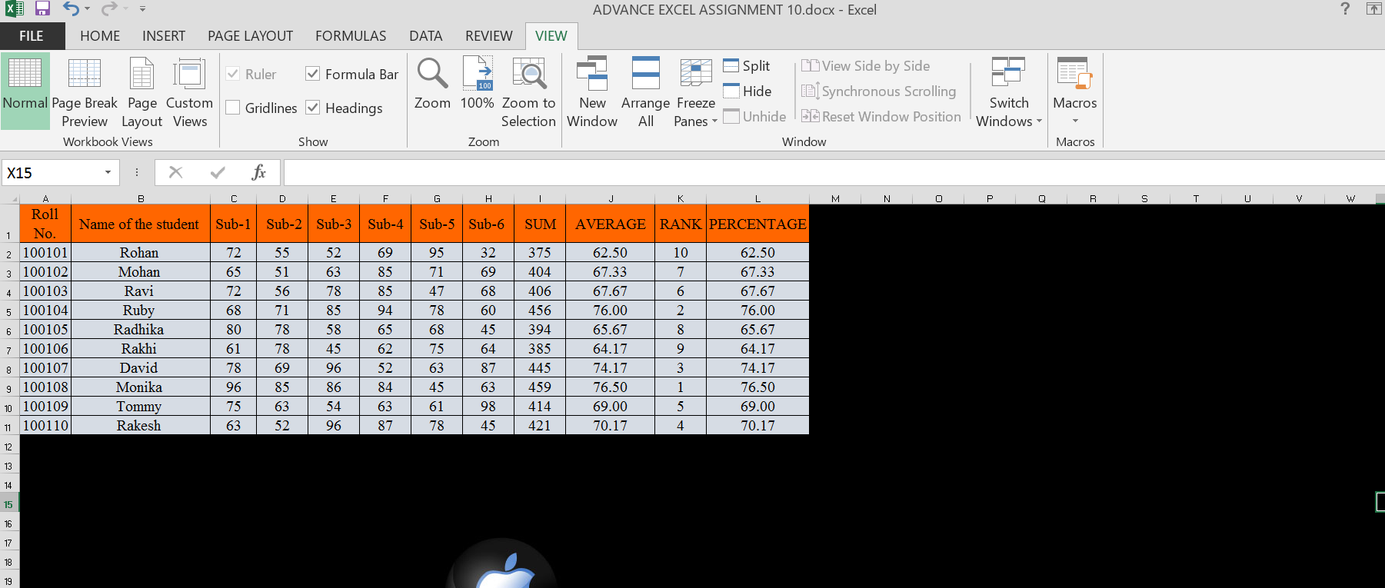

3. What is freeze panes and why do we use freeze panes? Give examples.

Answer: Freeze Panes is used to lock specific rows and columns in place. While working with large datasets, the user sometimes need to keep the row or column headers visible at all times at that time freezing panes helps the user to see the desired row/column even while scrolling.

For example:

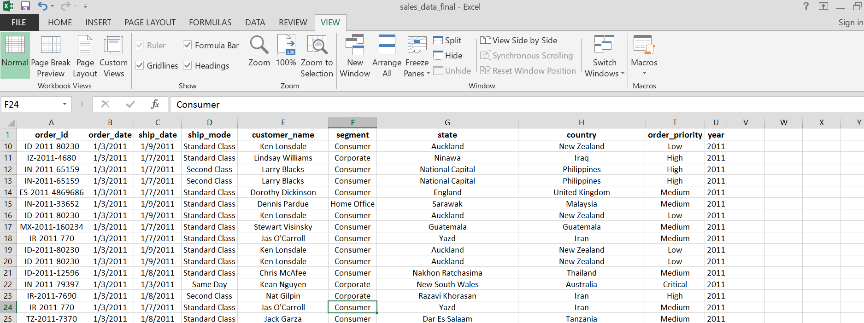

4. What are the different features available within the Freeze Panes command?

Answer: There are three options in the Freeze Panes:

Unfreeze panes: It unfreezes freezes the rows/columns.

Freeze Top Row: It freezes all the rows above the active cell.

Freeze First Column: It freezes all the columns to the left of the active cell.

5. Explain what the different sheet options present in excel are and what they do?

Answer:

1. Gridlines:
   1. View option allows to show/ hide gridlines within the active worksheet and turning off this option removes the gridlines from the sheet and displays a blank Excel sheet.
   2. Print allows to show/ hide gridlines on an Excel document that will be printed on paper.
2. Headings:
   1. View option allows to show/ hide headings within the active worksheet and turning off this option removes the headings from the current sheet's headers and footers.
   2. Print option allows to show/ hide headings on an Excel document, which is to be printed on paper.
3. Print Area: We can select the print area using this option. We can drag and select the area or range of cells by using the mouse.
4. Print Titles:
   1. Rows to repeat at top: This option helps us select the title to display at the top for corresponding rows.
   2. Columns to repeat at left: This option helps us select the title to display on the left side for columns.
5. Print:
   1. Gridlines: This option can be enabled or disabled by selecting/ deselecting the checkbox. It helps us decide whether to show gridlines or not on printed Excel documents.
   2. Black & White: Like the gridlines, we can select this checkbox to print the current Excel document in black and white color, even if we have the color printer attached.
   3. Draft Quality: Selecting the checkbox associated with the draft quality allows us to print the Excel document using the printer's draft-quality settings.
   4. Rows & Column Heading: We can select this option to display rows and columns headings to the printed Excel documents.
6. Page Order:
   1. Down, then Over: This option allows users to print the down page first and then the right pages.
   2. Over, then Down: This option allows users to print the right pages first and then the down pages.
7. Print: Clicking on this option gives a command to the device to print the current Excel document using the default printer.
8. Print Preview: This option displays the preview of the Excel document that will be printed on paper.
9. Options: This option allows users to choose layout type (portrait or landscape) and paper mode (A4, A5, etc.) for the Excel document to be printed.